OU UNHCR

f7 The UN Refugee Agency

WHAT HAPPENS WHEN YOU CLAIM ASYLUM AT THE BORDER?

CLAIMING AT AN OFFICIAL BORDER POST:

An immigration officer at the border will decide if you meet one of the exceptions under the Canada-U.S. Safe Third Country Agreement (STCA). Read our document “Who can claim asylum at the border?\* and get legal advice before you claim asylum in Canada.

You will be arrested by the police and questioned about your irregular entry

CLAIMING AT THE BORDER IN-BETWEEN OFFICIAL BORDER POSTS:

You wS be brought to the nearest official border post Bring your ID documents (passports, driver s license, birth certificates, etc) to prove your identity

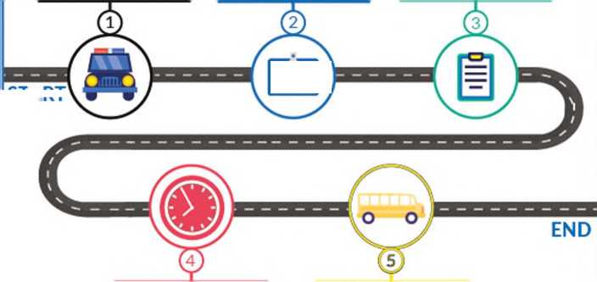

START

You might have to stay more than a day at the border. Bring basic items you might need during your wait (food/drinks, diapers, medication, etc.)

You will be transported to the nearest main city. Transportation is usually free but you might have to pay for transport or make your own travel arrangements (pick up by friends, taxi, etc.)